

**Advanced Battery Management System (ABMS)**

**FREQUENTLY ASKED QUESTIONS**

**Q:** Which phones are compatible with the app?

**A:** Most iPhones and Android phones are compatible.

**iPhones:** For the best user experience, we recommend iPhone 6 or later. ABMS requires at least iOS 10.

**Android:** Any phone that supports pixel density: xhdpi, xxhdpi and xxxhdpi. ABMS requires at least OS 6.

**Q:** Are there other devices that are compatible with the ABMS app?

**A:** No, only iPhones and Android phones can support the app at this time.

**Q:** Why does the app appear grainy on my tablet?

**A:** While the app will work on some tablets, it is designed to be used on a phone. For the best experience, the app should be viewed from a compatible (see above) iPhone or Android phone.

**Q:** Why, when I try to view the app on an iPad in landscape mode, don’t the app tools rotate properly?

**A:** The app is designed to be viewed in portrait mode. Rotating the screen may cause issues with the appearance of some app functions.

**Q:** What languages options are available for the ABMS app?

**A:** Currently, only English is supported but we are working on other languages to add later.

**Q:** In which countries can the app be downloaded?

**A:** The Augmented Reality app is allowed wherever Apple and Android apps can be downloaded. For a Country list, please visit:

**Apple:** [Click here](https://support.apple.com/en-us/HT204411)

**Google:** [Click here](https://support.google.com/googleplay/answer/143779)

**Q:** How far away from the machine will the ABMS app work?

**A:** Data should be available up to approximately 30 feet from the machine.

**Q:** On the fleet level screen, which machine will show up first?

**A:** The machine with the strongest Bluetooth signal will populate first. Typically, this is the machine closest to your device.

**Q:** Does the ABMS app show data for each battery or for the entire battery stack?

**A:** The ABMS app shows data from the entire battery stack.

**Q:** What alerts are generated by the app?

**A:** The app includes active alerts for the machine controller, battery charger and DTC’s

**Q:** On the 5 cycles tab, what do the dots mean?

**A:** Each dot represents a single cycle which is every time the battery is plugged in then unplugged.

**Q:** What does SOC % mean?

**A:** State of charge % (SOC %) refers to the relative level of energy left on your machine when compared with a fully charged machine.

**Q:** What are the most common reasons why batteries fail?

**A:** Improper charging/discharging. For optimal battery usage, batteries should maintain an 80% SOC to reduce battery deterioration. Proper charging and discharging methods are detailed in the app, under the “I” icon. Another common cause for battery failure is improperly watering or failure to water batteries. Only distilled water should be used for watering.

**Q:** Why would the battery not be charging if it is plugged in?

**A:** Check the power source where the charger is plugged in. The power supply could potentially be turned off, not plugged in, or have poor power quality (e.g., low voltage power pole).

**Q:** What does VDC refer to:

**A:** Voltage Direct Current, which provides a steady current as opposed to an alternating current.

**Q:** What does it mean If the app shows 0.0 VDC?

**A:** The mobile control module may not be connected to the machine CAN Bus. Refer to the machine’s electrical schematic for connection assistance.

**Q:** Why is the app not showing charger information?

**A:** The charger may not be connected to the mobile control module or the charger has transitioned into sleep mode and will need to be plugged in to the AC to reset. Refer to the machine’s electrical schematic for connection assistance.

**Q:** Why is the app different than the machine indicator light?

**A:** While unlikely, this discrepancy is possible when the battery energy has been substantially depleted. In this case, the app displays the amount of energy remaining in the battery, whereas the machine indicator is showing the machine’s ability to continue to function.

**App Icon Descriptions:**

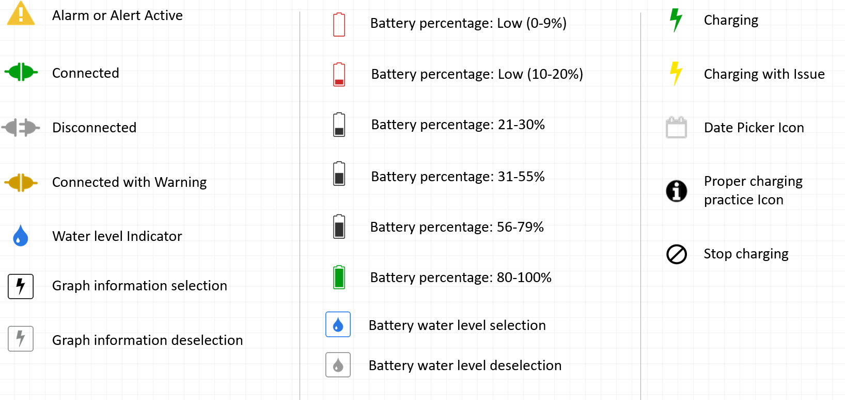

**Q:** What feature is enabled with the hardware:

**A:** See below

|  |  |  |  |  |  |
| --- | --- | --- | --- | --- | --- |
| **Features** | **Sub Categories** | **Smart Charger** | **Local Functionality via Mobile App** | **Remote Functionality via Clearsky Portal** | **Remote Functionality via Clearsky Portal** |
|  | **Hardware required** | **Smart Charger** | **Smart Charger, Mobile Control Module** | **Smart Charger, Mobile Control Module, ClearSky CAN Hardware** | **Smart Charger, ClearSky CAN Hardware** |
| SOC | Improved SOC | ● | ● | ● | ● |
| Alerts/ Notifications | Alerts | ● | ● | ● | ● |
| No charge DTC | ● | ● | ● | ● |
| No charge alert | ● | ● | ● | ● |
| Fault Code | Charger fault code identification | ● | ● | ● | ● |
| Algorithm | Universal algorithm 17 | ● | ● | ● | ● |
| Ability to change charger algorithm | ● | ● | ● | ● |
| Battery Freeze Warning | Antifreeze alert, accurate SOC (freeze prevention) | ● | ● | ● | ● |
| Depletion | Battery depletion tracking | ● | ● | ● | ● |
| Fluid Level Monitoring | Required watering alarm and water date tracking | ● | ● | ● | ● |
| History | Battery system history (last charge time and duration) | ● | ● | ● | ● |
| Charger history | ● | ● | ● | ● |
| Remote Diagnostics | Remote diagnostics | ● | ● | ● | ● |

|  |  |
| --- | --- |
| ● | Solution available and easy to use |
| ● | Solution available, but have to view info through the handheld analyzer |
| ● | Solution not available |